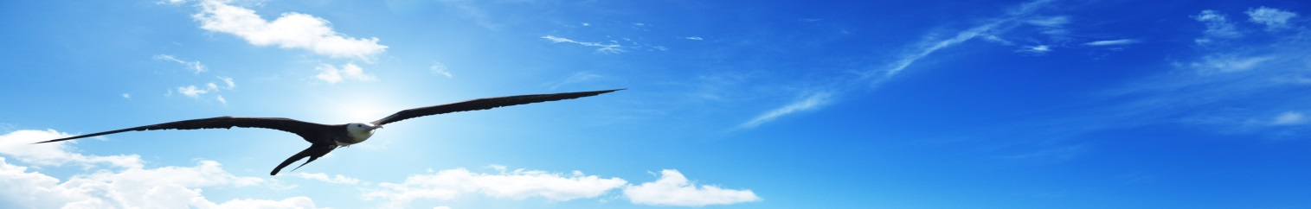
NATO DEFENSE COLLEGE FOUNDATION
STRATEGIC TRENDS
May 2016
EASTERN EUROPE
Belarus’s crush between the West and Russia
On 3 April, Pavel Yakubovich, the chief editor of the main media outlet of the Belarusian government, described the meeting of the US Deputy Assistant Secretary of Defense Michael Carpenter with senior Belarusian defence officials and President Aleksandr Lukashenko, ‘the event of the week’. Indeed, after a decade of break in bilateral relations, this has been a first step to reopen the dialogue, including in the security and defence arena.
The event, considered by Russia as another western interference in its geopolitical sphere, received a swift response. Few days after, Russia announced its willingness to build up a joint air defence system. This has not been the first joint project between Moscow and Minsk, but, as many others, it could remain on paper without Belarusian cooperation.
Although Russian media have already proclaimed the establishment of a ‘single system in Eastern European region’, whose participants are only Minsk and Moscow, President Lukashenko has made neutrality his foreign policy hallmark. Notably, he agreed to open in Minsk the negotiations between Russia and Ukraine, and remained neutral on controversial issues, such as Russia's conflicts with Georgia, Ukraine and Turkey. His posture in foreign policy has the aim at making Belarus a more acceptable partner for the EU and the United States in the near future.
Certainly, Belarus has been resisting Russian attempts to take over the management of its security. For instance, when Belarus needed to acquire modern fighter aircrafts to enhance its air force, Russia’s proposal was that the country hosted a Russian airbase. However, President Lukashenko declined the offer and successfully insisted on the aircraft purchase. If Russia had carried out successfully this project, its air defence would have moved forward by hundreds of kilometres, directly bordering NATO members Lithuania and Poland, previously separated from Russia by a hypothetically neutral Belarus, and would have deepened the isolation of the Baltic states from the NATO’s main European allies.
Nowadays, Minsk’s purpose is to avoid being squeezed by the increasing military activities of NATO and Russia. The risk of a war in Eastern Europe seems unlikely to be realistic for the time being, but Minsk wants to defuse even the narrative of a new Cold War and the reopening of channels the West seems a good strategy for its own survival.

